7 GOD GIVES YOU ASSURANCE  IDENTITY  CERTAINTY  • Nothing can separate me from the  PROMISES  • He who began a good work in me  8 GOD'S GRACE & YOUR WORKS  9 SPIRITUAL GROWTH  The Bible uses several Spiritual Growth metaphors to help us understand that; WE ARE BORN TO GROW.  Root → Fruit Newborn → Mature Milk → Meat  “Therefore, as you received Christ Jesus the Lord,  so walk in him,” Colossians 2:6  “bearing fruit in every good work and increasing in  the knowledge of God.” Colossians 1:10 | Jesus is God - Bible is God’s Word  Jesus said: “I am the way, and the truth, and the life. No one comes to the Father except through me.” John 14:6  True:  • God is one God in 3 persons: Father/Son/Spirit.  Matthew 28:19; Deuteronomy 6:4  • Jesus is the only way to God. John 14:6  • Jesus alone saves from sins. Acts 4:12  • Bible is God’s Word to mankind. 2 Timothy 3:16–17  • Bible alone, no other books or teachings. Gal. 1:8–9  False:  • Jesus is a son of God, but not God. John 1:1; John 20:28  • Jesus is a God and the Father is another God.  Deuteronomy 6:4; John 10:30  • Other books and/or teachings are needed to correctly  know and interpret the Bible. 2 Timothy 3:15–17  • The Bible and other books together are authoritative  teachings from God. Mark 7:8–13; Galatians 1:8–9  Other religions with a false teaching of Jesus:  • Islam: Jesus is a prophet, not God.  • Hinduism: Do not affirm Jesus as the one true God.  • Buddhism: Jesus is not affirmed as God.  • Judaism: Jesus is not accepted as Messiah or God.  YOUR CONTACT AND CHURCH REFERENCE  Scripture quotations are from the English Standard Version (ESV).
  • I am loved by God. | Col 3:12
  • I am adopted into God’s family. | Rom 8:15
  • I am a temple of the Holy Spirit. | 1 Cor 6:19
  • I am never alone. | Mt 28:20
  • I have direct access to God. | Eph 2:18
  • I am a new creation in Christ. | 2 Cor 5:17
  • I have meaning and purpose. | Eph 2:10
  • God hears prayer according to His will. | 1 Jn 5:14–15
  love of God. | Rom 8:31‑39
  • I have a living hope. | 1 Pet 1:3–4
  • The old is gone; the new has come. | 2 Cor 5:17
  • He will give me clear direction. | Pr 3:5‑6
  • In Temptation God provides way of escape. 1 Cor 10:13
  • I am forgiven. | 1 Jn 1:9
  will complete it. | Phil 1:6
  Grace: For by grace you have been saved through faith. And this is not your own doing; it is the gift of God, not a result of works, so that no one may boast. Ephesians 2:8–9
  Works: For we are his workmanship, created in Christ Jesus for good works, which God prepared beforehand,
  that we should walk in them. Ephesians 2:10
  • Seed — New life in Christ. 1 Pet. 1:23
  • Root — Established in Christ. Col. 2:6–7
  • Plant — Growing in a life with Christ. 1 Cor. 3:6–7
  • Fruit — Our service for others’ growth. Jn. 15:5, 8
  TOPIC | Roots (New) | Fruit (Mature)
  God’s Word | Read & learn | Study, recall, share, defend
  Holy Spirit | Receive & Rely | God’s enabling power to act
  Fellowship | Meet & share | Mentor, lead, teach, guide
  Evangelism | Learn, train | GO, share, reproduce
  Discipleship | Practice & grow | Teach, model & mentor
  10 | CHOOSING A CHURCH FAMILY  What is True? — What is False?
  Churches teaching Jesus as God:
  • Bible / non-denominational churches
  • Baptist (Southern Baptist, Conservative Baptist)
  • Pentecostal / Charismatic
  • Christian / Christian Missionary Alliance Churches
  Churches with false teachings of God:
  • Latter-day Saints (Mormon): Jesus and the Father are separate gods; they reject the Trinity
  • Jehovah’s Witnesses: Jesus is God’s Son, not Almighty God; identified with Michael the archangel.
  • Iglesia ni Cristo (Church of Christ): Jesus is human.
  F O L L O W M E
  MINISTRIES LLC ©
  Phone: 713-922-5030
   | New Life in Jesus
  F | Follow Me Matt. 4:19  Follow Me is a Christian ministry working together with many churches to share the love of Jesus.
  O | We can know for sure that our sins are forgiven and that we have eternal life with God in heaven.
    Offers Good News | Eph. 1:7; 1 Jn. 5:13
  L | Our sin separates us from a holy God. We cannot escape His judgment through our own efforts.
    Living Apart from God | Rom. 3:23; 6:23
  L | Jesus came to save us. He died to take upon Himself the penalty for our sins and rose again so that we could have new life in Him.
    Love of God | 1 Cor. 15:3‑4
  O | Confess that Jesus is God and trust Him as your Savior. Ask Him to forgive your sins and come into your life. Ask God to secure you with His Holy Spirit and lead you in His ways.
    Our Response | Rom. 10:9‑13
  W | No one can make this response for you. Personally receive Jesus in faith. Express that faith through a prayer like this. Pray now:
    Welcome Jesus | Eph. 1:13‑14
    • Jesus, I believe that You are God.
    • You died for my sins and rose again to give me eternal life with You.
    • Forgive my sins. Come live in me.
    • Seal me forever with Your Holy Spirit to lead and guide me.
    • Thank You for eternal life. Amen.
  M | Through faith in Jesus, you are born again into a new life. Your sins are forgiven, and you are adopted into God’s family.
    Made New | 2 Cor. 5:17; Rom. 8:15
  E | Just as a newborn baby learns and grows, you now begin to grow in your new spiritual life. The following pages will help you learn to follow Jesus.
    Embrace His Ways | 2 Cor. 3:18
2 WHAT JUST HAPPENED?  You have a new life in Christ.  3 WHO IS GOD?  ATTRIBUTES  FATHER: Creates Plan  • His will is the redemption of mankind to come to Him and advance His Kingdom.  SON (JESUS): Puts Plan into Place  • Jesus’ sacrifice on the cross provided a pathway for mankind to be saved from sin and live purposeful lives advancing God’s will.  HOLY SPIRIT: Puts Plan into Action  • The Spirit drew us to Jesus and is actively empowering, guiding and giving us life purpose.  THE HOLY SPIRIT EMPOWERS  “for apart from me you can do nothing.” John 15:5  “But you will receive power when the Holy Spirit has come upon you” Acts 1:8 | 4 WHO AM I?  God created mankind in His likeness to know Him and live in fellowship with Him. He gave us the ability to commune with Him, make moral choices, and exercise our will. But we chose our own way. Our sin separated us from a holy God and brought us under eternal judgment. In His great love, God sent His Son Jesus to die in our place and pay the price for our sin. When we trust Jesus, we receive new life and an eternal relationship with God. We begin our life in Christ still struggling with sin that we cannot overcome on our own. We must depend upon the Holy Spirit to guide and empower us throughout our lives as we move past our natural ways and grow towards the New Self, which is being renewed in God’s image and becoming more like Christ.  5 WHAT DOES GOD EXPECT FROM ME?  Trust/Rely/Prioritize/Obey  Love God/Others  Read/Pray/Apply/Walk/Grow  Fellowship/Worship/Teach/Share  Respect/Mercy/Working/Giving | 6 GOD'S SPIRIT DIRECTED LIFE  1. Spirit - The Core From within, the indwelling Spirit leads/guides/directs.  2. Prayer/Bible - The Head Our communication and devotion with God.  3. Fellowship/Worship - The Arms Our big hug of love for God and for one another.  4. Service/Discipleship - The Legs Stepping out to give of ourselves, show mercy, win the lost and disciple believers.  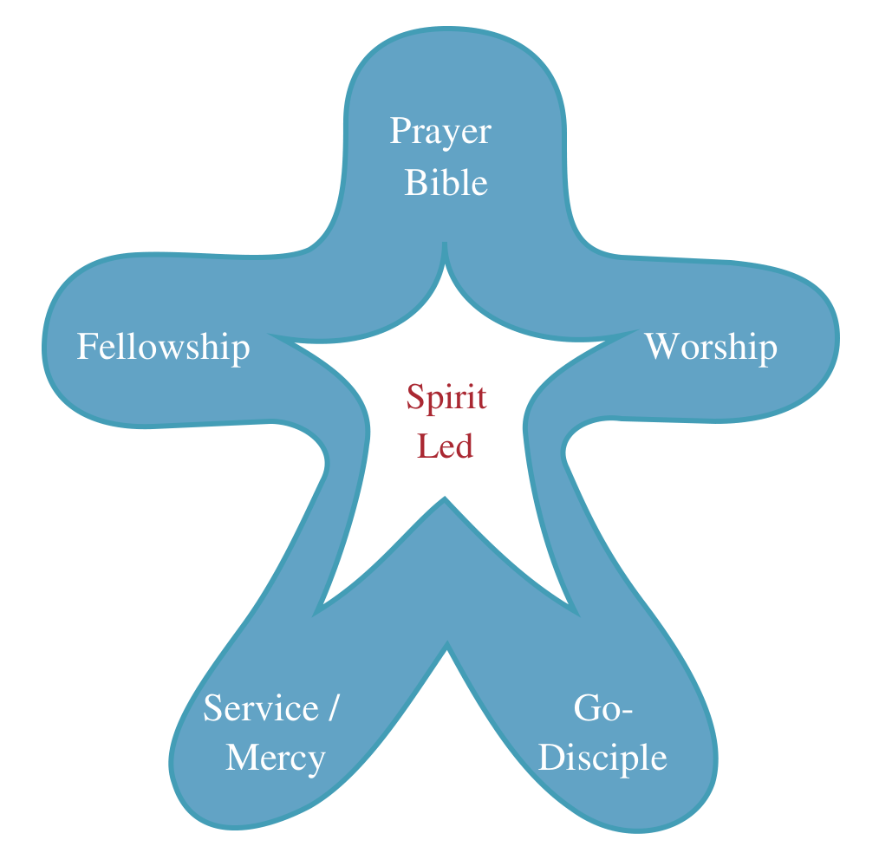  Fellowship  Worship  Prayer /  Bible  Service /  Mercy  Go-  Disciple  Spirit  Led  ©
  And this is the testimony, that God gave us eternal life, and this life is in his Son. Whoever has the Son has life; whoever does not have the Son of God does not have life. 1 John 5:11–12
  God is spirit, and those who worship him must worship in spirit and truth. John 4:24
  • God is Love. | 1 John 4:8
  • God is all knowing. |  |  |  | Psalms 139:1‑6
  • God is all powerful. |  |  |  |  | Jeremiah 32:17
  • God is Truth. |  |  |  |  |  | John 14:6
  • God is righteous. |  | Psalm 145:17
  • God is merciful. |  |  | Romans 9:15‑16
  • God is faithful. |  |  |  | 2 Timothy 2:13
  • God is Holy. |  |  |  | 1 Peter 1:15–16
  One Eternally Existent God
  In three distinct persons:
  Father, Son, Spirit
  • Power unto Salvation: The Holy Spirit gives us new life and dwells in us. Titus 3:5; Rom. 8:9
  • Power for our daily Living: We depend on His
  leadership and continual filling. Gal. 5:16; Eph. 5:18
  • Power for Ministry: We ask for His power to serve and proclaim Jesus boldly. Acts 1:8; 4:31
  • Power for Others: The Holy Spirit convicts hearts and draws people to Himself. We obey; God causes these things to happen. Jn. 16:8, 14; 1 Cor. 3:6–7
  “and have put on the new self, which is being renewed in knowledge after the image of its creator.”
  Colossians 3:10
  • Trust the Lord with your whole heart. | Proverbs 3:5‑6
  • Put Jesus first. | Matthew 6:33
  • Rely upon God’s strength. | Philippians 4:13
  • Deny sinful desires. | Gal 5:24
  • Love God with entire self. | Matthew 22:37
  • Love one another. | John 13:34‑35
  • Read/Learn Memorize Bible. | Psalms 119:11
  • Pray, Talk to God. | Phil 4:6–7
  • Obey God’s Word. | John 14:15‑24
  • Walk by Spirit, not flesh. | Galatians 5:16
  • Grow in Christ. | 2 Peter 1:3‑15
  • Fellowship together regularly. | Heb 10:25
  • Worship and honor God. | Nehemiah 8:5‑6
  • Teach God’s instruction. | Deut 6:6–7
  • Help others understand Scripture. | Acts 18:24‑28
  • Share Jesus with others. | Mark 5:19
  • Disciple others. | 2 Timothy 2:2
  • Live Respectful before all. | 1 Peter 2:17
  • Love mercy, walk humbly. | Micah 6:8
  • Work as unto the Lord. | Colossians 3:23‑24
  • Give to God’s work. | 2 Corinthians 9:7
  If we live by the Spirit, let us also keep in step with the Spirit.
  Galatians 5:25
  Just as living without an arm or a leg is severely limiting, the same is true for our Christian lives. Each area of our spirit-led life must be kept in balance and exercised to be fully useful, effective and satisfied.
  1. Spirit Led/Directed | Ez 36:27; Rom 8:14
  2. Bible | 2 Tim 3:16
  3. Prayer | Phil 4:6‑7
  4. Worship | Ps 95:6; Jn 4:23‑24
  5. Fellowship | Heb 10:24–25; Rom 12:4–5
  6. Mercy/Giving/Service | Gal 5:13‑14
  7. (GO) Evangelism | Rom 1:16
  8. Disciple | Matt 28:18‑20

